BMS INSTITUTE OF TECHNOLOGY & MANAGEMENT

Yelahanka, Bengaluru – 560 064



Department of Computer Science and Engineering

Synopsis for the Project work

“Pressure Ulcer Prediction and Prevention”

Submitted By:

1. A Nitya Dyuthi 1BY18CS001

2. Khuswinder Singh 1BY18CS074

3. Likith S 1BY18CS081

4. Prakhyat 1BY18CS108

Under the Guidance of

Mrs. Durga Bhavani A

2021-2022

BMS INSTITUTE OF TECHNOLOGY, BANGALORE-560064



**Students Project Review and Assessment Committee**

**Intermediate Report-Phase I**

| **Batch No:**  **15** | | **Guide Name:**  **Mrs. Durga Bhavani A** | | **Submission Date:**  **09-11-2021** |
| --- | --- | --- | --- | --- |
| **Project Title**    **Pressure Ulcer Prediction and Prevention** | | | | |
| **Sl No** | **USN** | | **Name** | |
| **1** | **1BY18CS001** | | **A Nitya Dyuthi** | |
| **2** | **1BY18CS074** | | **Khuswinder Singh** | |
| **3** | **1BY18CS081** | | **Likith S** | |
| **4** | **1BY18CS108** | | **Prakhyat** | |
| **Project Execution Place** | | | **In-house** | |
| **Project Category** | | | **Research and Societal** | |

**Signature of HoD Signature of the Guide SPARC**

**Abstract**

Pressure ulcers (PU) or Decubitus ulcers (DU) are localized injuries to the skin or underlying tissue, usually over a bony prominence, as a result of unrelieved pressure. They are deep scars that can reach up to the bones and are extremely painful. They affect people that do not have much ambulation and are bound to a bed all day long. The proposed system includes predictive and preventive methods to solve the issue of bedsores. The predictive solution involves measuring pressure and moisture levels and taking corrective measures to prevent painful bedsores, and the preventive measure is to use a mattress to aid in redistributing pressure from a concentrated area. The mattress consists of a set of air pockets. The pressure in the air pockets surrounding the pressurized area is changed so that the pressure on said area of the body is reduced, thereby preventing bedsores.

**Introduction**

Older people, whether staying at home, hospitals, or retirement homes, incur the risk of health symptoms and problems. Due to the advent of COVID-19, the number of cases where the patient is prescribed bed rest is soaring. In many cases, some form of monitoring is helpful to aid the healthcare personnel in preventing the degradation of the patient’s health status. Decubitus ulcers (DU), also called bedsores or pressure ulcers, are wounds that develop when the skin undergoes constant pressure for a prolonged duration. Due to bony prominence, the common sites for DU include heels, shoulder blades, elbow, and coccyx/sacrum (gluteal). They are a common injury that mainly plagues elders and frail people, and is a major cause of concern in medical institutions. Current screening and prevention techniques for assessing risk for decubitus ulcer formation and repositioning patients every 1-3 hours are labor-intensive and can be subjective.

According to statistics of the Center for Disease Control (CDC), DUs affect 2.5 million people yearly, and that also includes 1.6 lakh patients in nursing homes. There is a huge amount of money spent (~$11.6 Billion) on the treatment of DUs every year in the United States alone.

We have proposed a system using low-cost, disposable wireless, and unobtrusive fabric-based pressure sensors and hygrometer (to measure moisture levels on the skin) to continuously monitor the tissue status in at-risk areas already developed to detect the pressure and make the necessary adjustments to the bed to prevent the same.

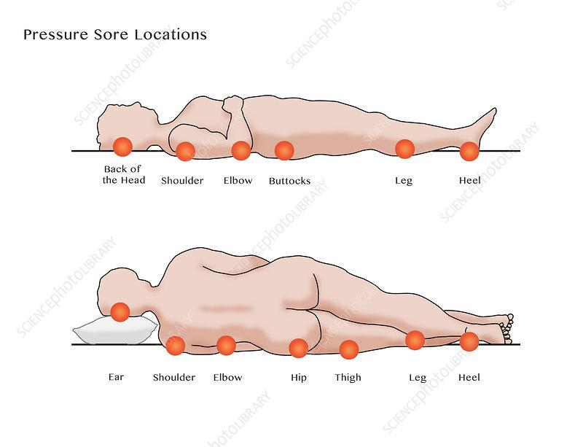

Fig 1: Bedsores pressure points in the human body

**Problem Statement**

Decubitus Ulcers are dangerous and can have severe consequences, leading to long-term hospitalization. At more severe stages, bedsores become very painful, and the patient is at risk of surgery and even death. The goal of this project is to predict and prevent the formation of bedsores without human intervention. Prevention techniques in hospitals and retirement homes today are still traditional, where the healthcare personnel/caretaker spends a considerable amount of time regularly checking the status of their patients and their changes in body position and other body parameters. In the proposed system, data is gathered from an array of ambient pressure sensors to evaluate the vulnerable areas depending on the total time of impact and other factors.

**Literature Review**

Multiple decubitus ulcer risk assessment tools are used worldwide with the most popular being the Braden, Norton, and Waterlow scales. Braden scale[1] is the most widely used scale and is used to score various parameters in six subscales, concerning the physical status of the subject, like sensory perception, skin moisture, activity, mobility, friction and shear, and nutritional status. After evaluation of all the parameters, a score is arrived at, which indicates how susceptible the subject is to a DU. While quantitative, scoring can be subjective and studies have shown high variability in scoring between clinicians. Based on the score, the subject is monitored by the caregiver.

There are various wearable devices to help in detecting (lack of) ambulation, and if there is none for a long period, the caretakers are alerted and action is taken[9][7]. Other publications mention the use of image classification[4][10] to detect bedsores using logistic regression, KNN clustering, and other deep learning techniques. IoT techniques are also used for real-time monitoring of the subjects using various sensors[2].

The other set of publications mention the use of sensors such as FSR (Force Sensing Resistor), pulse oximeter (SPO2), pulse and heart rate sensor, humidity, temperature sensors to analyze the physical conditions, and ambulation and predict the formation of a DU.

The publications that deal with the prevention of DUs, use mattresses[6][8][11] in various ways, like, increasing area of contact, decreasing pressure, using different kinds of materials like sheepskin[3], dialysis bags[5], CME (Combustion Modified Ether)[3] foam mattresses are suitable for those up to the medium risk of developing a pressure ulcer. Visco mattresses are suitable up to high risk or very high risk etc., to predict as well as prevent the formation of a DU.

Assessment is typically performed during admission, discharge, and changes in the patient’s condition. Prevention and management of decubitus ulcers involve patient repositioning and pressure redistribution devices. Patient repositioning typically occurs every 1-2 hours to prevent tissue ischemia, though the determination of timing is arbitrary. Patients at high risk of or have already acquired a decubitus ulcer are managed with special support surfaces such as foam or gel cushions that relieve or redistribute pressure.

**Limitations of Existing System**

The current prediction of a pressure ulcer occurrence is using the Braden Scale approach or Waterlow Scale approach, which requires a lot of human intervention and often takes up a lot of attention from the caretakers, which prevents them from serving their actual purpose. The scoring in these scales is highly subjective. The mattresses used in hospitals and homes for DU patients only consider pressure as the only factor, and ignore other critical factors that affect the formation of DUs like physical conditions, temperature, moisture, etc...

**Research Gaps and Challenges**

Body pressure dispersion mattresses are useful tools for preventing pressure ulcers. Pressure-reducing mattresses redistribute a patient's weight to relieve pressure points, but critical factors such as physical conditions and moisture are usually ignored. Another important factor to consider is the comfort of the patient, which is often overlooked. A suitable fabric/mattress that minimizes the shearing effect and also provides good aeration and ventilation to the subjects is also disregarded.

**Proposed System Architecture & methodology**

The solution we propose is divided into two parts: prevention and prediction. The prediction involves two factors: pressure and moisture. We propose monitoring the pressure values from FlexiForce™ pressure sensor in real-time and comparing it against a set threshold value. If the threshold (400mm Hg) is crossed for a duration of time (4 to 6 hours), we take action that will be explained. For the moisture component, we measure the value via the moisture sensor, and using the data and the trained model, we predict the formation of a DU.

The main goal in prevention is to reduce pressure and that can be done either by increasing the area of contact or decreasing the force on the body part. Moisture increases as the area of contact increases and so, the chances of a DU increase. We must consider moisture and pressure in preventing a DU.

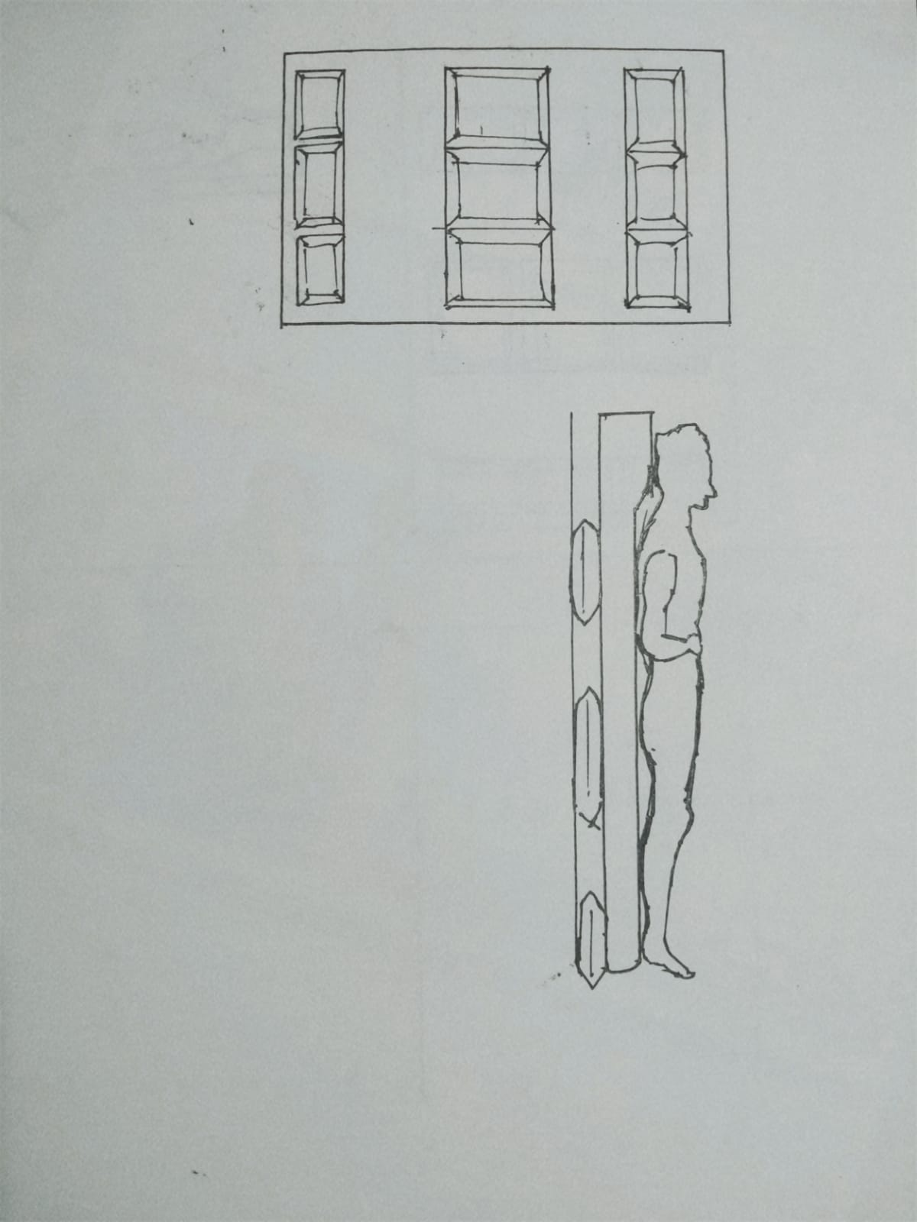

Our solution for prevention involves a mattress that is fabricated with air pockets situated evenly across the mattress. These air pockets can be inflated and deflated using a microcontroller and a portable air pump, based on the real-time pressure sensor readings. The air pockets have a layer of the cotton sheet over them, which is also connected to a pump to aerate humid areas and to make the mattress comfortable. the area of contact will have the air pockets deflated and the surrounding air pockets will be inflated. This will result in reduced pressure and increased aeration in the vulnerable area.

Body pressure distribution is constantly measured by the pressure sensors. Temperature and humidity are measured by using ambient temperature and humidity sensors. The inner pressure of each air cell is adjusted according to the site-specific body pressure data, temperature, and humidity. The pressure of the air cell is maintained by controlling the valves. The output valve is opened for a specified period to reduce the air pressure and the inlet valve is opened to increase the air pressure.

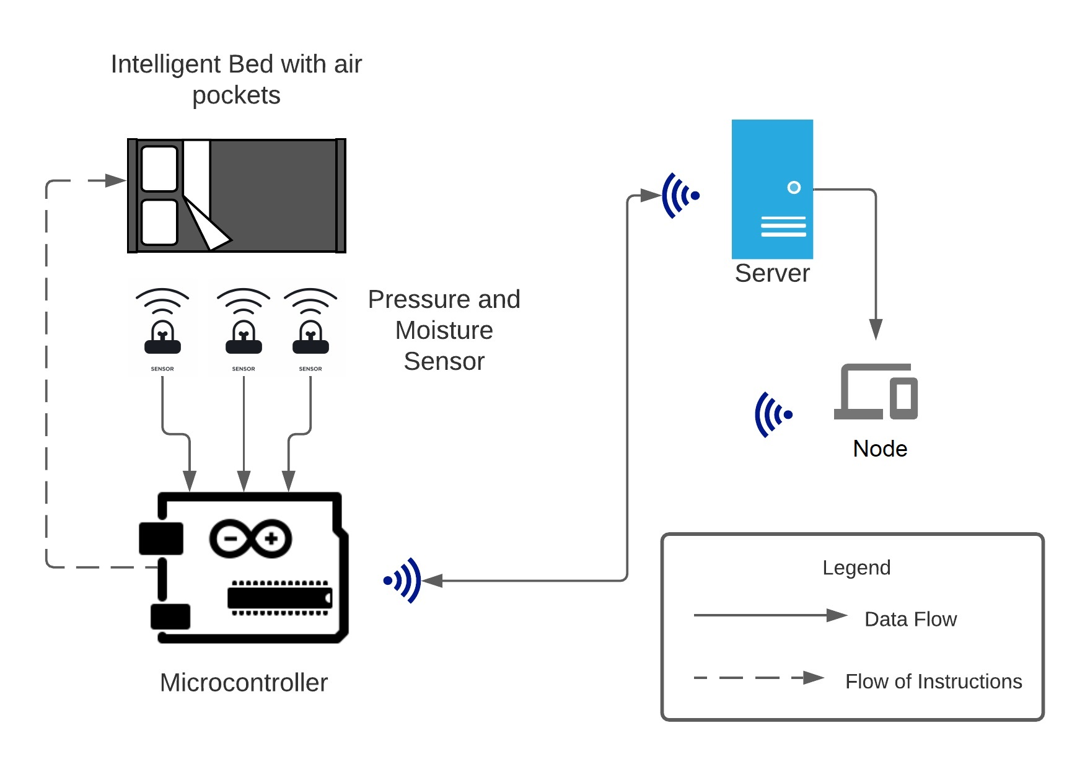

Fig Architecture Diagram

**System Requirement Specifications (Hardware & Software)**

**Hardware Requirements**

* Arduino Uno R3
* SCX30ANC pressure sensor
* SEN-13322 moisture sensor
* NodeMCU ESP8266
* NW miniature air pump 5V-6VDC 400KPA 370

**Software Requirements**

* Notification Service
* Arduino IDE
* Browser
* Python
* Windows OS
* NodeJS

**Expected Outcome**

The problem can be solved by using an IoT-based approach by utilizing an array of pressure and moisture sensors for prediction and prevention. It uses a notification service to alert caretakers/healthcare personnel to take appropriate steps. The project also aims to minimize human intervention in monitoring and controlling decubitus ulcers using intelligent cushions that can be altered automatically based on the real-time pressure and moisture sensor values. Predicting the pressure ulcers will enable providing a good practice on bed condition for rehabilitation and accelerate safe and smooth support in bed-to-ambulation movement**.** This low-cost approach reduces costs and is better not just economically but also relieves the physical and psychological burden of caregivers.

**References**

# [1] [N Bergstrom](https://pubmed.ncbi.nlm.nih.gov/?term=Bergstrom+N&cauthor_id=3299278), [B J Braden](https://pubmed.ncbi.nlm.nih.gov/?term=Braden+BJ&cauthor_id=3299278), [A Laguzza](https://pubmed.ncbi.nlm.nih.gov/?term=Laguzza+A&cauthor_id=3299278), [V Holman](https://pubmed.ncbi.nlm.nih.gov/?term=Holman+V&cauthor_id=3299278), The Braden Scale for Predicting Pressure Sore Risk: https://pubmed.ncbi.nlm.nih.gov/3299278/

[2] **Sam Mansfield.,Eric Vin.,Katia Obraczka(2021). An IoT System for Autonomous, Continuous, Real-Time Patient Monitoring and Its Application to Pressure Injury Management.** doi:[10.1109/ICDH52753.2021.00021](https://doi.org/10.1109/ICDH52753.2021.00021)

[3] **Functional textiles for prevention of pressure ulcers**

<https://www.emerald.com/insight/content/doi/10.1108/RJTA-10-2019-0047/full/html>

[4] [**Bilge Yilmaz**](https://ieeexplore.ieee.org/author/37086937469)**.,** [**Ercan Atagün**](https://ieeexplore.ieee.org/author/37085555621)**.,** [**Fadime ÖĞÜLMÜŞ Demırcan**](https://ieeexplore.ieee.org/author/37088979735)**.,** [**İbrahim Yücedağ**](https://ieeexplore.ieee.org/author/37085773171)**(2021). Classification of Pressure Ulcer Images with Logistic Regression.** doi:[10.1109/INISTA52262.2021.9548585](https://doi.org/10.1109/INISTA52262.2021.9548585)

[5] [**Therdpong Daengsi**](https://ieeexplore.ieee.org/author/38234558800)**.,**[**Bundit Muttisan**](https://ieeexplore.ieee.org/author/37088972879)**.,** [**Pongpisit Wuttidittachotti**](https://ieeexplore.ieee.org/author/37085384865)**.,** [**Patsita ., Sirawongphatsara**](https://ieeexplore.ieee.org/author/37085501633) **(2021). Sustainable Development of a Prototype of Air Mattress from Re-used Materials for Pressure Ulcer Prevention.** doi:[10.1109/GECOST52368.2021.9538773](https://doi.org/10.1109/GECOST52368.2021.9538773)

[6] [**Malindu Ehelagastenna**](https://ieeexplore.ieee.org/author/37088963383)**.,** [**Ishan Sumanasekara**](https://ieeexplore.ieee.org/author/37088964057)**.,** [**Hishan Wickramasinghe**](https://ieeexplore.ieee.org/author/37088964813)**.,** [**Indrajith D. Nissanka**](https://ieeexplore.ieee.org/author/37086962866)**.,** [**Gayani K. Nandasiri**](https://ieeexplore.ieee.org/author/37088965424)**(2021).Design of an Alternating Pressure Overlay for the Treatment of Pressure Ulcers.** doi:[10.1109/MERCon52712.2021.9525787](https://doi.org/10.1109/MERCon52712.2021.9525787)

[7] [**Eman Elsharif**](https://ieeexplore.ieee.org/author/37088904101)**.,** [**Nabil Drawil**](https://ieeexplore.ieee.org/author/37398909200)**., Salaheddine** [**Kanoun**](https://ieeexplore.ieee.org/author/37088903982)**(2021)Automatic Posture and Limb Detection for Pressure Ulcer Risk Assessment.** DOI: [10.1109/MI-STA52233.2021.9464360](https://doi.org/10.1109/MI-STA52233.2021.9464360)

[8] [**Zeinab Shayan**](https://ieeexplore.ieee.org/author/37086309025)**.,** [**Mohammad Sabouri**](https://ieeexplore.ieee.org/author/37086933950)**.,** [**Milad Shayan**](https://ieeexplore.ieee.org/author/37088841852)**.,** [**Mohammad Hassan Asemani**](https://ieeexplore.ieee.org/author/38467584900)**.,** [**Ali Bina Sarmoori**](https://ieeexplore.ieee.org/author/37088841101)**.,** [**Mohammad Zare**](https://ieeexplore.ieee.org/author/37088841274)**(2021). Pressure control of cellular electromechanical medical mattresses for bedsore prevention.** DOI: [10.1109/ICCIA52082.2021.9403585](https://doi.org/10.1109/ICCIA52082.2021.9403585)

[9] [**Eun-Bin Park**](https://ieeexplore.ieee.org/author/37088643518)**.,**[**Jin-Chul Heo**](https://ieeexplore.ieee.org/author/37088641214)**.,** [**Chanil Kim**](https://ieeexplore.ieee.org/author/37422430600)**.,** [**Beomjoon Kim**](https://ieeexplore.ieee.org/author/37088644852)**.,** [**Kwangyeol Yoon**](https://ieeexplore.ieee.org/author/37088643699)**.,** [**Jong-Ha Lee**](https://ieeexplore.ieee.org/author/38566958400)**(2020).Development of a Patch-Type Sensor for Skin Using Laser Irradiation Based on Tissue Impedance for Diagnosis and Treatment of Pressure Ulcer.** DOI: [10.1109/ACCESS.2020.3048242](https://doi.org/10.1109/ACCESS.2020.3048242)

[10] **Kottner, J., Cuddigan, J., Carville, K., Balzer, K., Berlowitz, D., Law, S., … Haesler, E. (2020). Pressure ulcer/injury classification today: An international perspective. Journal of Tissue Viability.** doi:10.1016/j.jtv.2020.04.003

[11] [**Brecht Serraes**](https://onlinelibrary.wiley.com/action/doSearch?ContribAuthorRaw=Serraes%2C+Brecht)**,**[**Martin van Leen**](https://onlinelibrary.wiley.com/action/doSearch?ContribAuthorRaw=van+Leen%2C+Martin)**,**[**Jos Schols**](https://onlinelibrary.wiley.com/action/doSearch?ContribAuthorRaw=Schols%2C+Jos)**,**[**Ann Van Hecke**](https://onlinelibrary.wiley.com/action/doSearch?ContribAuthorRaw=van+Hecke%2C+Ann)**,**[**Sofie Verhaeghe**](https://onlinelibrary.wiley.com/action/doSearch?ContribAuthorRaw=Verhaeghe%2C+Sofie)**,**[**Dimitri Beeckman**](https://onlinelibrary.wiley.com/action/doSearch?ContribAuthorRaw=Beeckman%2C+Dimitri)**(2018). Prevention of pressure ulcers with a static air support surface: A systematic review**. [doi.org/10.1111/iwj.12870](https://doi.org/10.1111/iwj.12870)